CS 340 README : Grazioso Salvare Rescue Animal Dashboard

About the Project/Project Title
The purpose of this project is to develop a full-stack dashboard that enables Grazioso Salvare to search, filter, and visualize data from the Austin Animal Center (AAC) Outcomes database. The dashboard allows users to identify dogs that meet specific search-and-rescue training criteria based on breed, age, and sex.
The application follows the Model-View-Controller (MVC) design pattern:
- Model: MongoDB database
- View: Dash dashboard interface
- Controller: Python CRUD module using PyMongo
This architecture separates data storage, business logic, and user interface, making the application easier to maintain and extend.

Required Functionality
The completed dashboard provides the following functionality:
- Displays an unfiltered view of the Austin Animal Center database.
- Allows users to filter dogs by rescue type:
  - Water Rescue
  - Mountain/Wilderness Rescue
  - Disaster/Individual Tracking
  - Reset (display all records)
- Displays an interactive DataTable.
- Displays a geolocation map that updates automatically when a row is selected.
- Displays a second visualization (Pie Chart) showing breed distribution.
- Includes the Grazioso Salvare logo.
- Includes a unique identifier containing my name.

Dashboard Demonstration

Initial Dashboard
The dashboard initially displays:
- Grazioso Salvare logo
- Dashboard title
- Rescue filter controls
- Interactive data table
- Geolocation map
- Breed distribution chart
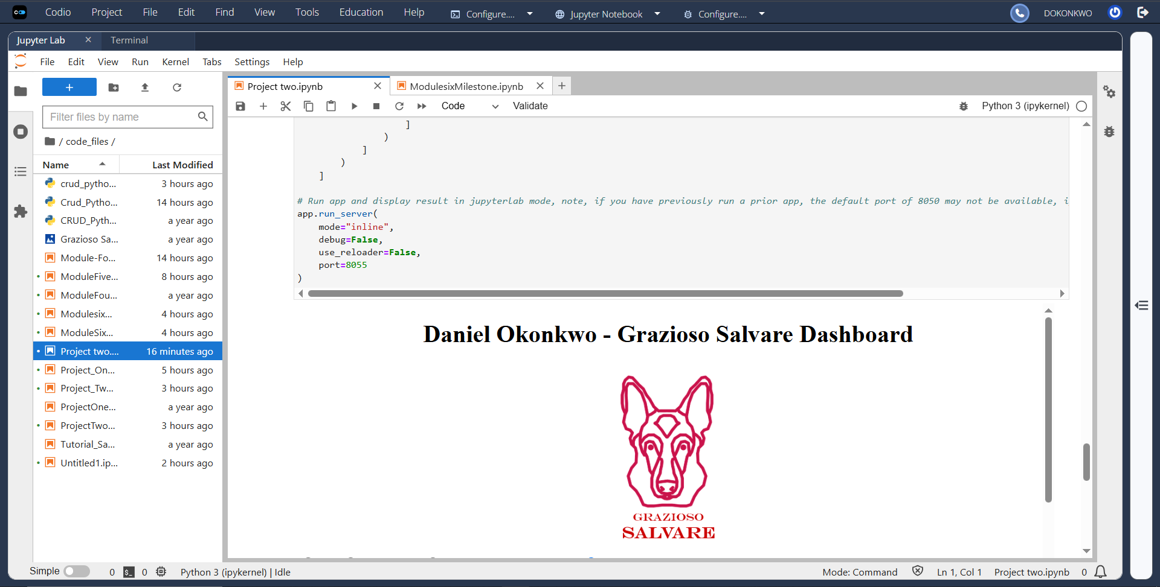

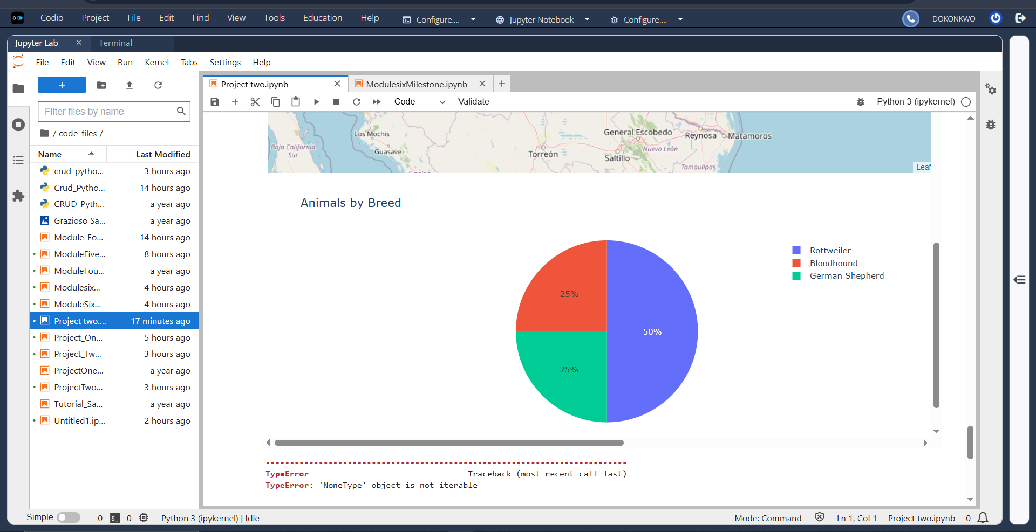

Water Rescue Filter
Selecting the Water Rescue option displays only dogs that satisfy Grazioso Salvare's Water Rescue requirements.
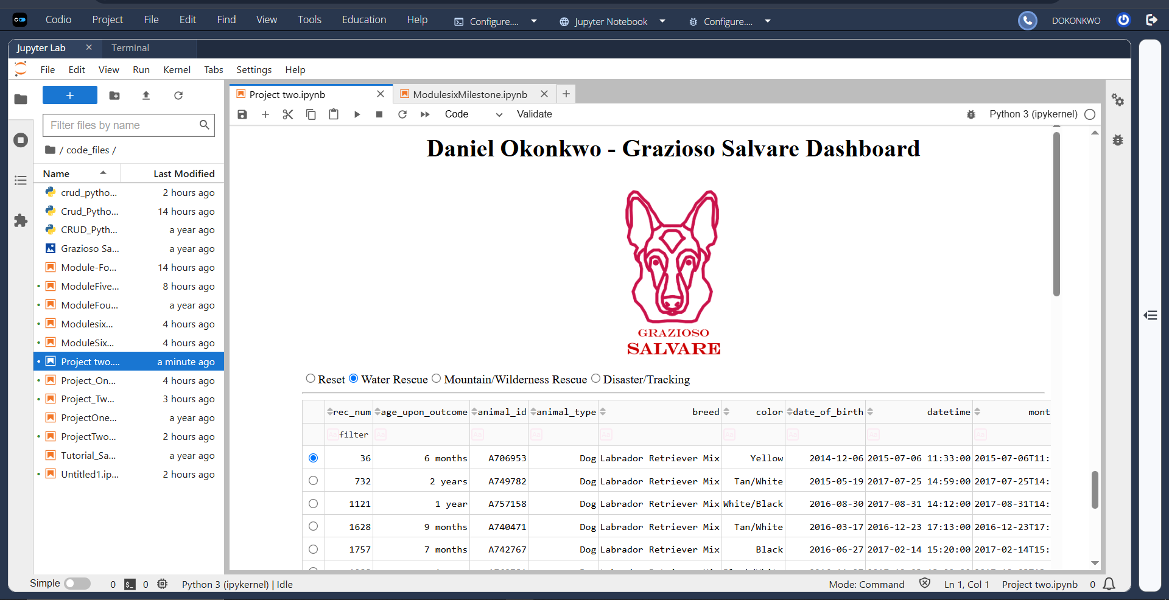

Mountain/Wilderness Rescue Filter
Selecting the Mountain/Wilderness Rescue option filters the dashboard to display only dogs meeting those requirements.
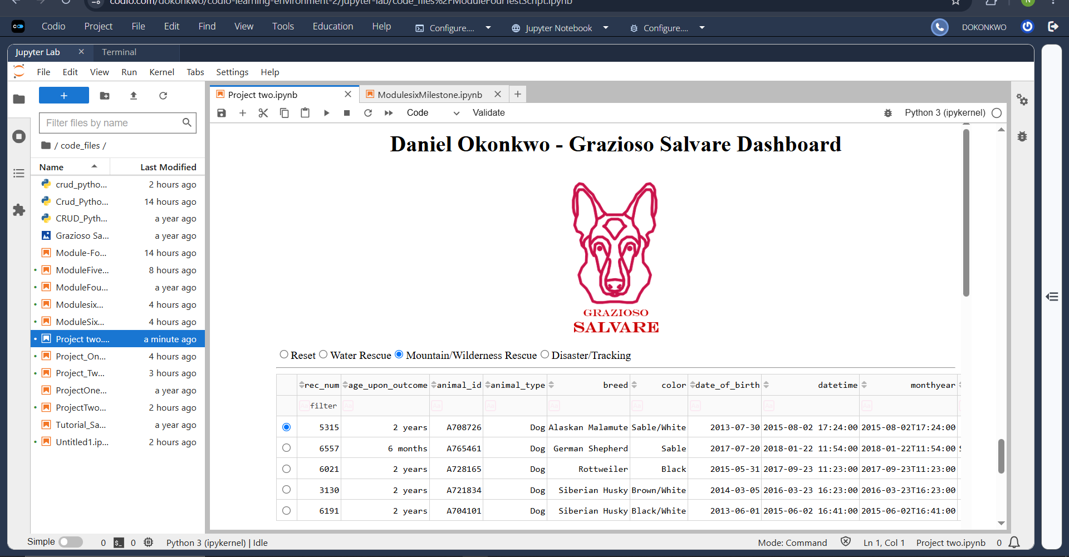

Disaster/Individual Tracking Filter
Selecting Disaster/Individual Tracking displays only dogs matching the specified search criteria.
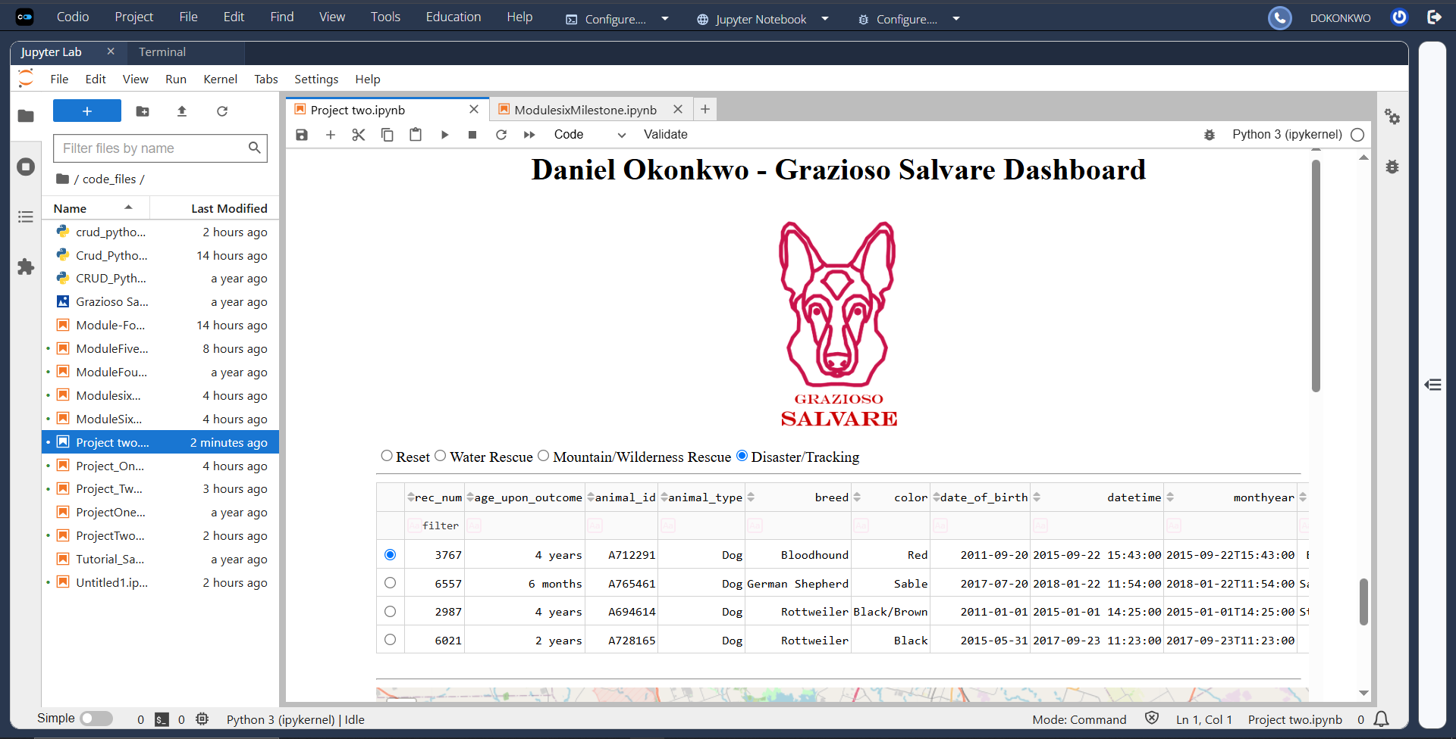

Reset
Selecting Reset restores the dashboard to the complete Austin Animal Center data set.
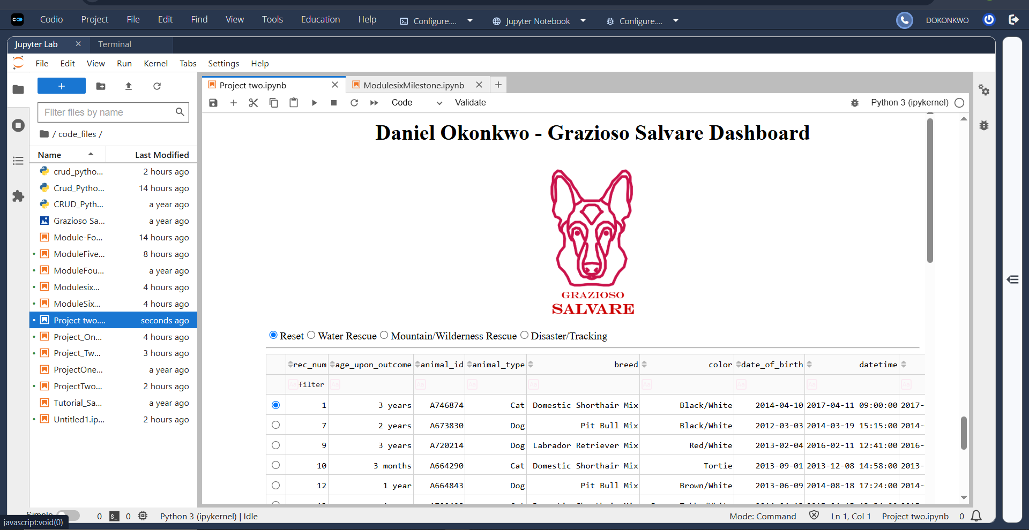

Software and Tools Used

MongoDB
MongoDB was selected because it is a document-oriented NoSQL database that stores data as BSON documents. This structure closely matches Python dictionaries, making database interaction straightforward using PyMongo.
MongoDB provides:
- Flexible schema
- Fast document retrieval
- High scalability
- Native JSON document support
- Excellent integration with Python

PyMongo
PyMongo serves as the database driver between Python and MongoDB.
The CRUD Python module uses PyMongo to implement:
- Create
- Read
- Update
- Delete
Operations that are reused throughout the dashboard.

Python
Python was used as the primary programming language because of its readability, extensive libraries, and strong support for data processing and web development.
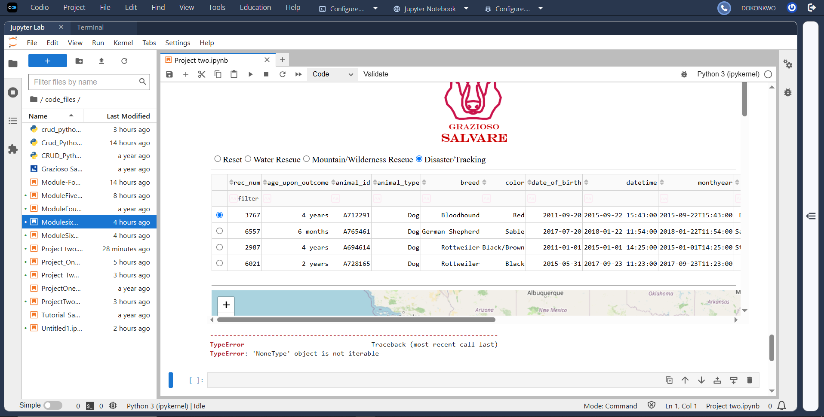
Dash Framework
Dash provides both the View and much of the Controller functionality of the application.
Dash was selected because it provides:
- Interactive dashboards
- Callback functions
- DataTable components
- Graphs
- Responsive layouts
Callbacks automatically update dashboard components whenever the user changes a filter or selects a different record.
Additional Libraries
- Pandas
- Plotly Express
- Dash DataTable
- Dash Leaflet
- NumPy
- JupyterDash
Reproducing the Project
Prerequisites
Install the required Python packages:
pip install pymongo dash dash-leaflet plotly pandas numpy
Import the Database
Import the Austin Animal Center CSV file:
cd ./datasets
mongoimport --type=csv --headerline --db aac --collection animals --drop ./aac_shelter_outcomes.csv
Create the MongoDB User
use admin
db.createUser({
user: "aacuser",
pwd: "YOUR_PASSWORD",
roles: [
{
role: "readWrite",
db: "aac"
}
]
})
Run the Dashboard
- Start MongoDB.
- Open ProjectTwoDashboard.ipynb.
- Ensure crud_python_file.py is located in the same directory.
- Update the username and password if necessary.
- Run all notebook cells.
- The dashboard will launch automatically.

Lessons Learned
This project strengthened my understanding of:
- MongoDB database management
- CRUD application design
- MVC architecture
- Object-oriented programming
- Python callback functions
- Dash dashboard development
- Interactive data visualization
- Client/server application development

Conclusion
The Grazioso Salvare Rescue Animal Dashboard successfully satisfies the project requirements by integrating MongoDB, Python, and the Dash framework into a fully functional client/server application. The dashboard enables users to search, filter, and visualize Austin Animal Center animal data through an intuitive interface while demonstrating reusable CRUD functionality, interactive visualizations, and a clean MVC architecture.

Contact
Your name: Daniel Okonkwo

